**Google Analytic Plugin Configuration**

1. **Google Analytic Setup**

* Go to [google analytics website](https://analytics.google.com/analytics/web/"  \l "/p319596296/reports/intelligenthome) and login in with your gmail account.
* Go to admin section at the bottom left and create a new property

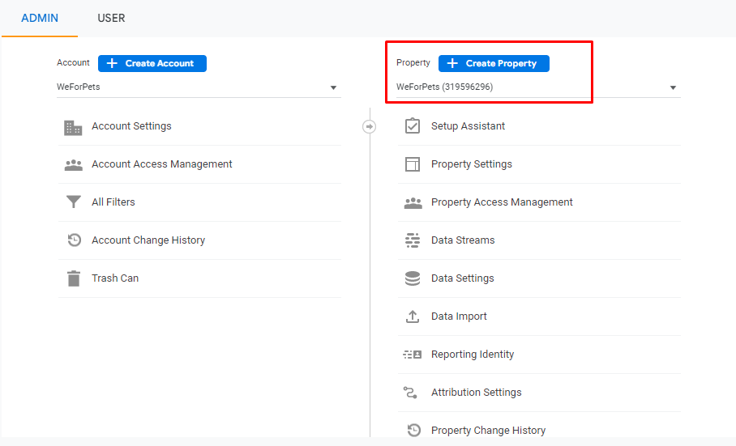

*Table 1 Admin Section*

* After creating a property, go to data streams under property and select web

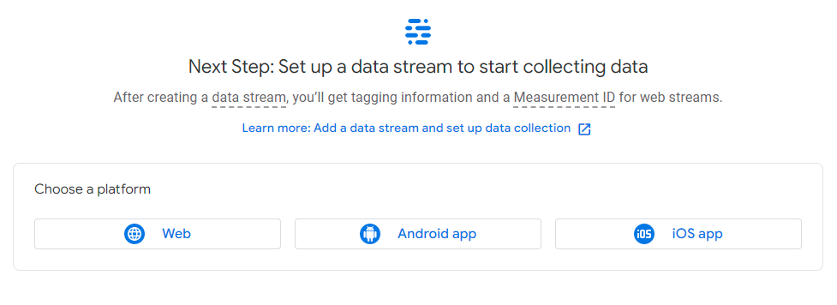

*Table 2 Data Stream Section*

* Fill the information and create stream

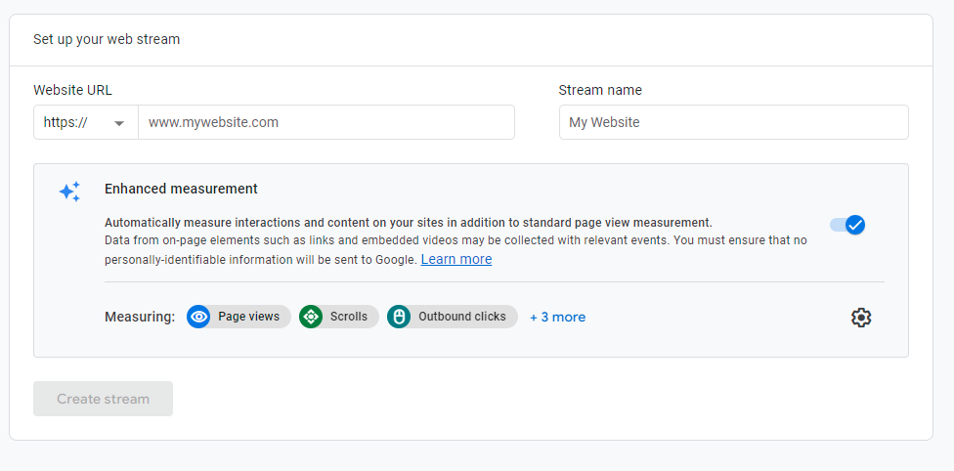

* Note down the measurement ID and contents of Global Tag site (gtag.js) under Tagging instruction --> Global site tag section

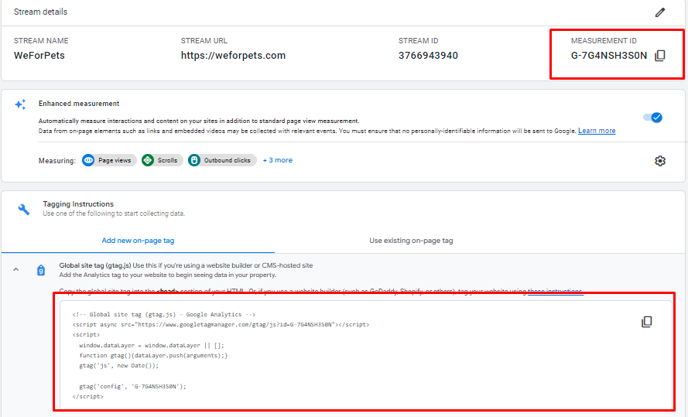

1. **Google Analytic Plugin nopCommerce setup**

**2.1 Activate**

To configure the Google analytics plugin:

Go to ****Configuration → Widgets****. The Widgets window will be displayed:

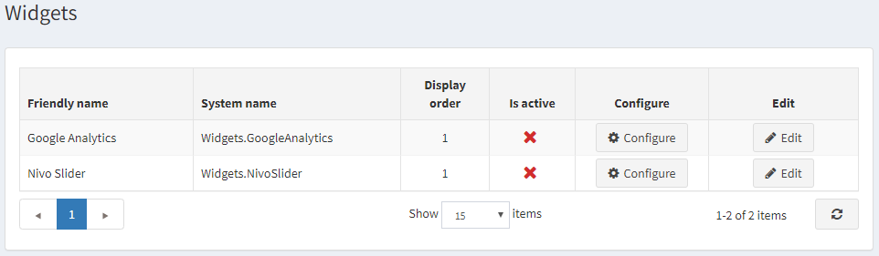

Click ****Edit**** beside ****Google Analytics****. The window will be expanded as follows:

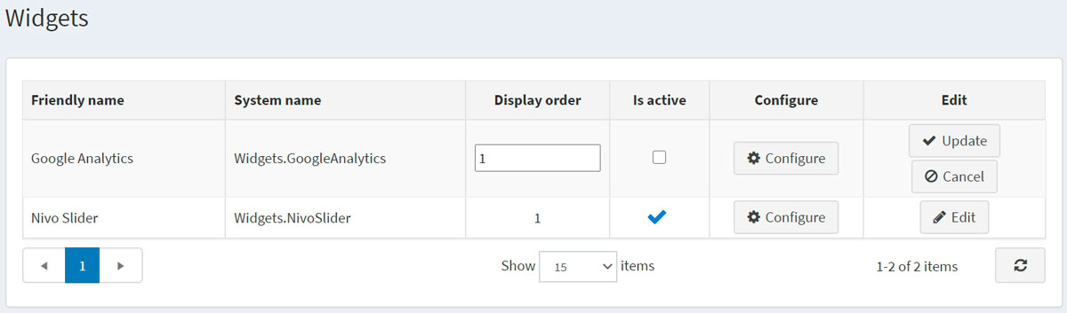

Select the ****Is active**** checkbox to enable the Google Analytics plugin. Then click the ****Update**** button to save the changes.

**2.2 Configuration**

* Go to admin section and search with the keyword ‘Analytics’

Or

select configure inside the widget option (in the above mentioned section)

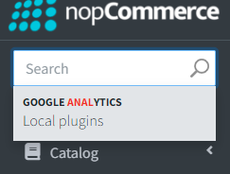

* Following page appears after the plugin is selected

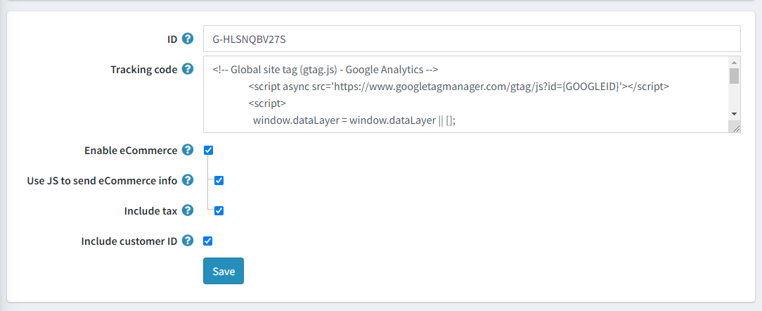

* Paste the Measurement ID into the ID section and gtag.js content into the Tracking Code section.
* Enable all other option as shown above and save.

Finally, google analytics is integrated into the store.